- FCFS Scheduling algorithm
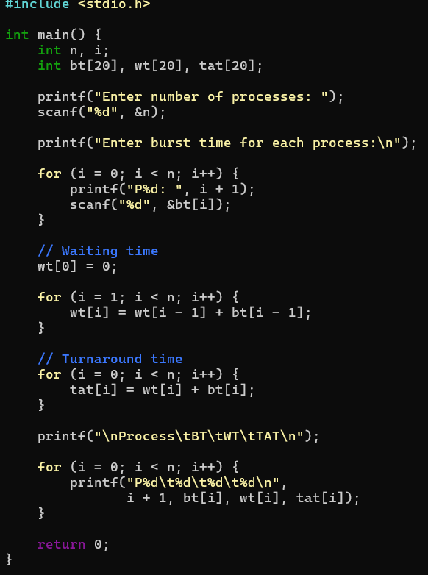
Out put :
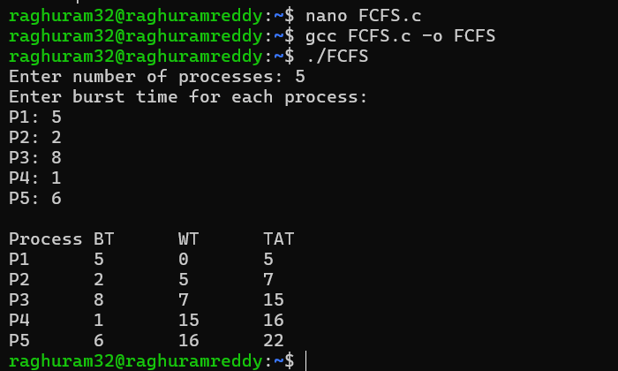

- SJF_NONpreemptive
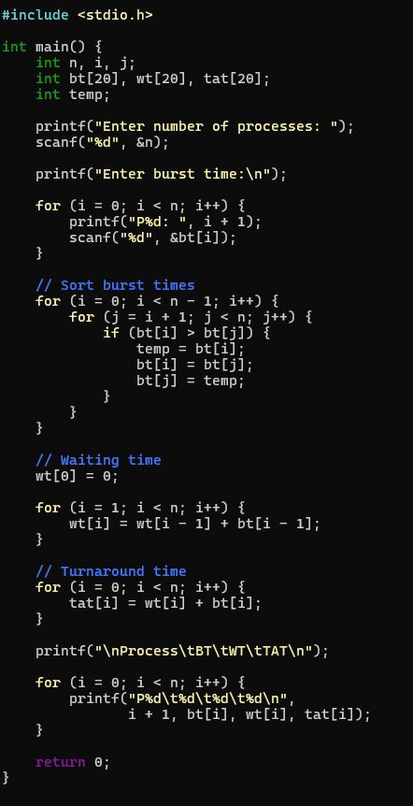
Out put :

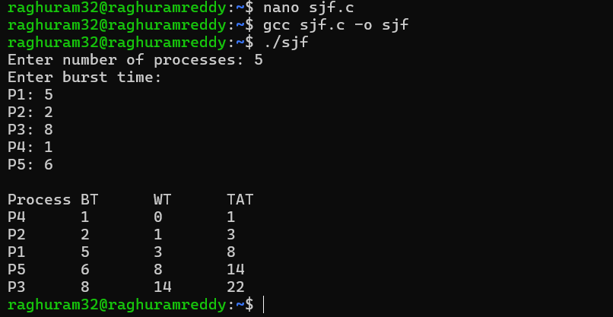

- Priority
#include <stdio.h>

int main() {
int n, i, j;
int bt[20], priority[20], wt[20], tat[20];
int temp;

printf("Enter number of processes: ");
scanf("%d", &n);

printf("Enter burst time and priority:\n");

for (i = 0; i < n; i++) {
printf("P%d Burst Time: ", i + 1);
scanf("%d", &bt[i]);

printf("P%d Priority: ", i + 1);
scanf("%d", &priority[i]);
}

// Sort according to priority
for (i = 0; i < n - 1; i++) {
for (j = i + 1; j < n; j++) {

if (priority[i] > priority[j]) {

temp = priority[i];
priority[i] = priority[j];
priority[j] = temp;

temp = bt[i];
bt[i] = bt[j];
bt[j] = temp;
}
}
}

// Waiting time
wt[0] = 0;

for (i = 1; i < n; i++) {
wt[i] = wt[i - 1] + bt[i - 1];
}

// Turnaround time
for (i = 0; i < n; i++) {
tat[i] = wt[i] + bt[i];
}

printf("\nProcess\tBT\tPriority\tWT\tTAT\n");

for (i = 0; i < n; i++) {
printf("P%d\t%d\t%d\t\t%d\t%d\n",
i + 1, bt[i], priority[i], wt[i], tat[i]);
}

return 0;
}
Out put :

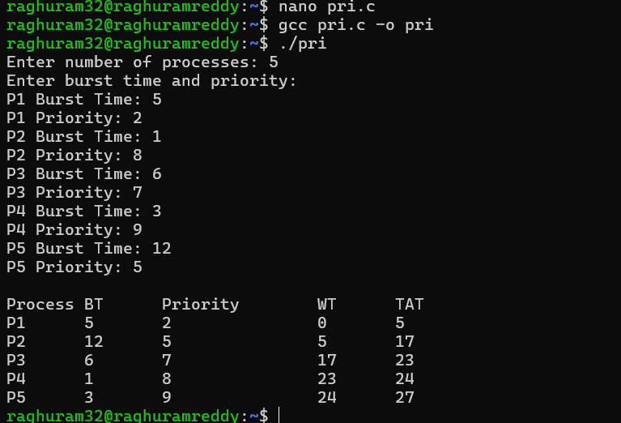

- ROUND ROBIN
#include <stdio.h>

int main() {
int n, i;
int bt[20], rem_bt[20];
int wt[20], tat[20];
int quantum;
int time = 0;
int done;

printf("Enter number of processes: ");
scanf("%d", &n);

printf("Enter burst time:\n");

for (i = 0; i < n; i++) {
printf("P%d: ", i + 1);
scanf("%d", &bt[i]);

rem_bt[i] = bt[i];
wt[i] = 0;
}

printf("Enter time quantum: ");
scanf("%d", &quantum);

// Round Robin
while (1) {

done = 1;

for (i = 0; i < n; i++) {

if (rem_bt[i] > 0) {

done = 0;

if (rem_bt[i] > quantum) {
time = time + quantum;
rem_bt[i] = rem_bt[i] - quantum;
}
else {
time = time + rem_bt[i];

wt[i] = time - bt[i];

rem_bt[i] = 0;
}
}
}

if (done == 1)
break;
}

// Turnaround time
for (i = 0; i < n; i++) {
tat[i] = wt[i] + bt[i];
}

printf("\nProcess\tBT\tWT\tTAT\n");

for (i = 0; i < n; i++) {
printf("P%d\t%d\t%d\t%d\n",
i + 1, bt[i], wt[i], tat[i]);
}

return 0;
}
Out put :

